Software Engineering Group 11

SE_11_PP_04

Project Plan – User Interface Design

Author: Gavin Reynolds (gar18), Kieran Dunbar (kid10), Jack Skitt (jas78)

Configuration Ref: SE_11_PP_04

Date: 2014-10-28

Version: 1.1

Status: In Review

Department of Computer Science

Aberystwyth University

Aberystwyth

Ceredigion

SY23 3DB

Copyright © Aberystwyth University 2014

Table of Contents

1. Introduction 4

1.1. Purpose of Document 4

1.2. Scope 4

1.3. Objectives 4

2. Colour Swatches 5

3. Website Basic Concepts 6

3.1. Page Structure 6

3.2. Link Styles 6

3.3. Footer Links 7

3.4. Navigation Links 7

4. Web User Interface Designs 7

4.1. Index Login Page 7

4.2. Registration Page 9

4.3. You Page – Account 11

4.4. View Page - Database 12

4.5. New Page – Database Entry 12

4.6. Logout – You Page 13

4.7. About Page 13

5. Database Schema 14

5.1. Schema Diagram 14

5.2. Description 14

5.2.1. Species Tables 14

5.2.2. Reserves Table 14

5.2.3. Recordings Table 15

5.2.4. Species Occurrence Table 15

5.2.5. Users Table 15

6. Android User Interface Design 16

6.2. Main Screen 16

6.2.1. Section A/B 16

6.2.2. Section C 16

6.2.3. Section D 16

6.3. Login Screen 17

6.4. Recording Screen 18

7. REFERENCES 19

8. DOCUMENT HISTORY 19

# Introduction

## Purpose of Document

The purpose of this document is to be an individual part of the final project plan, this is being kept as a separate document to allow for version control and drafting of this particular section.

## Scope

This document aims to be an overview of the User Interface Designs for the Website, Database and Android Application

## Objectives

This document covers:

* Colour (Theme) choices
* Website User Interface Designs
* Database Schema and Explanation
* Android Application User Interface Designs

# Colour Swatches

Swatch #0

Swatch #1

Swatch #2

Swatch #3

Swatch #4

**Hex References**

*References in order as to how the swatch is organised (left to right)*

**Swatch #0**

#42B49A #E5E5E5 #000000 #FFFFFF

**Swatch #1**

#BD4030 #E5E5E5 #000000 #FFFFFF

**Swatch #2**

#D17F00 #E5E5E5 #000000 #FFFFFF

**Swatch #3**

#545454 #E5E5E5 #000000 #FFFFFF

**Swatch #4**

#669900 #7FC123 #E5E5E5 #FFFFFF

# Website Basic Concepts

## Page Structure

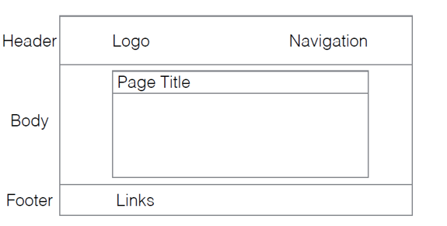

## Link Styles

* a:link (white)
* a:visited (white)
* a:hover (white)
* a:active (grey)
* Standard link (white)
* When on Page (grey)

## Footer Links

* About links to the About page
* GitHub links to the GitHub Repository
* Support will link direct to an email address

## Navigation Links

* You
* View
* New

# Web User Interface Designs

## Index Login Page

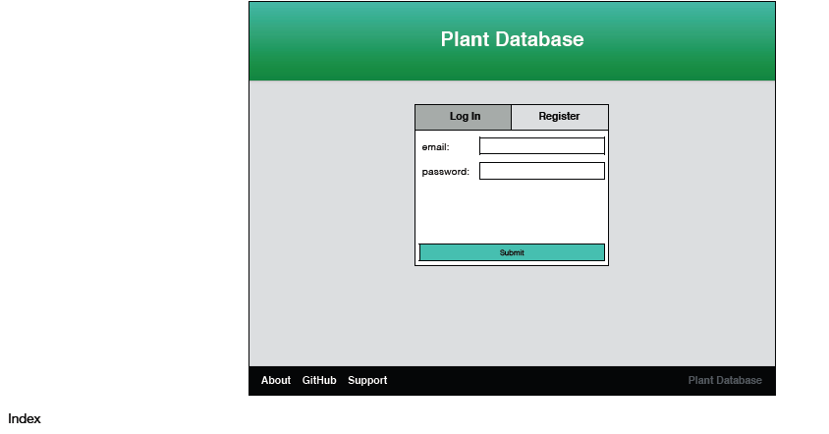

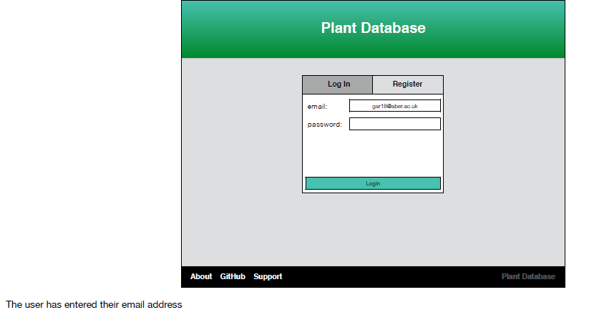

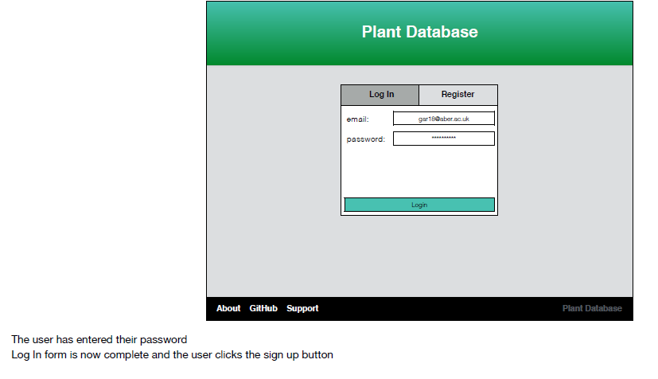

## Registration Page

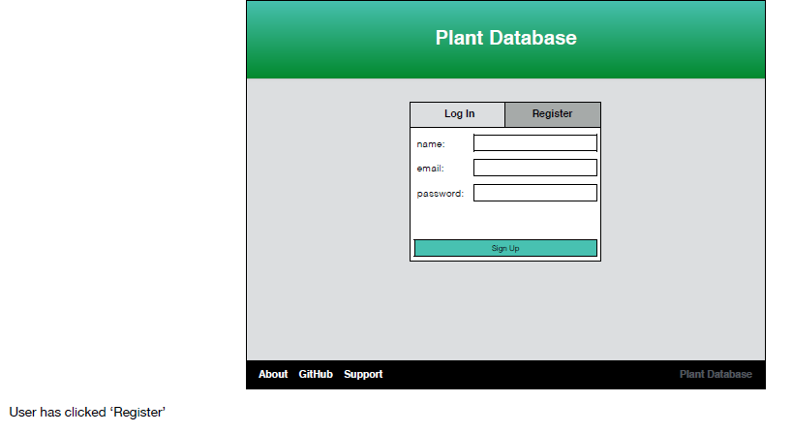

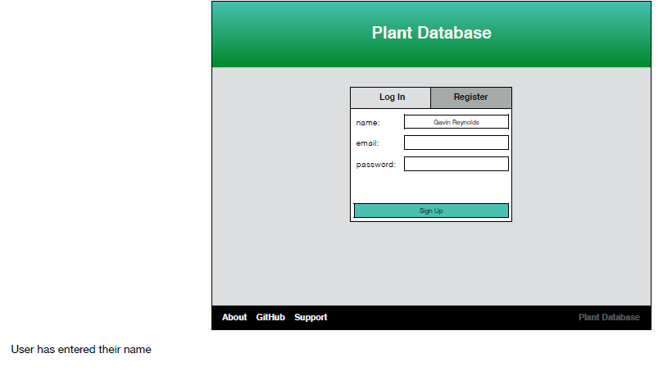

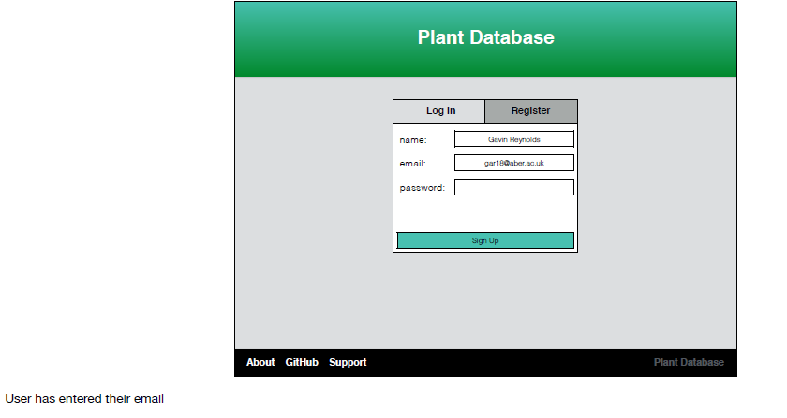

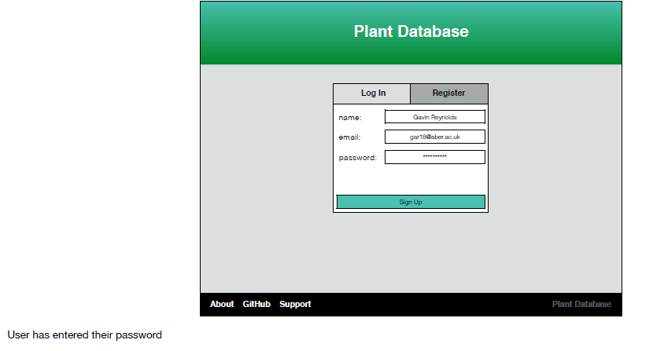

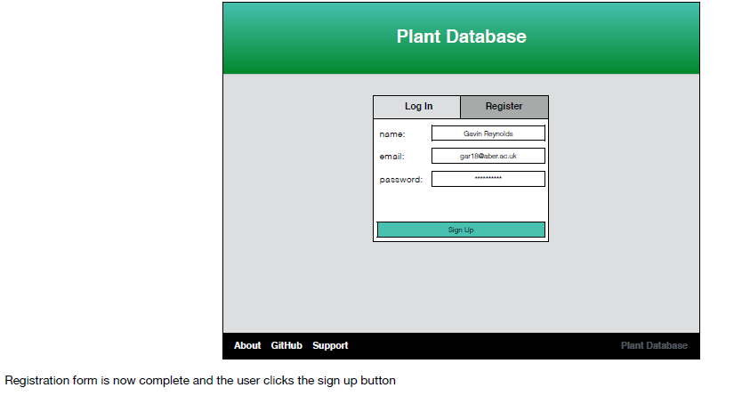

## You Page – Account

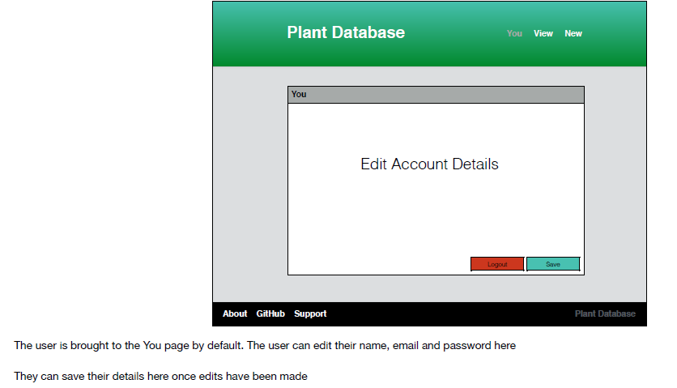

## View Page - Database

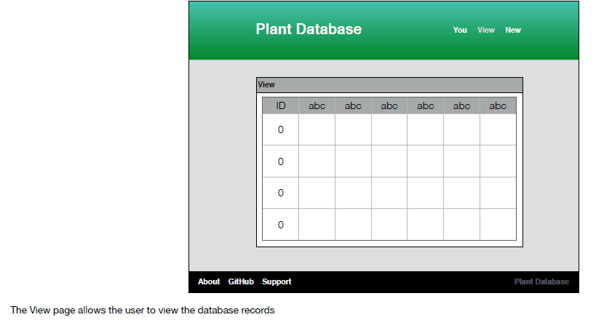

## New Page – Database Entry

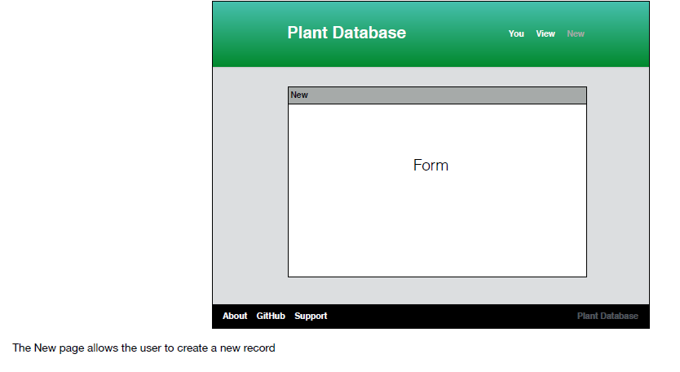

## Logout – You Page

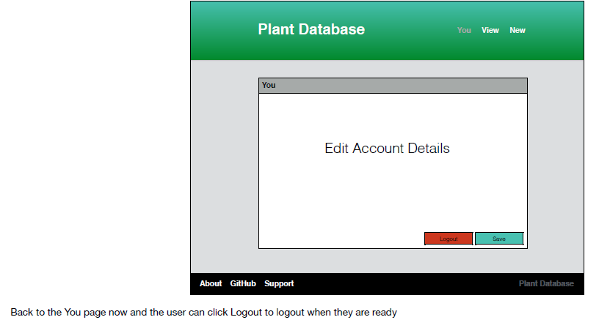

## About Page

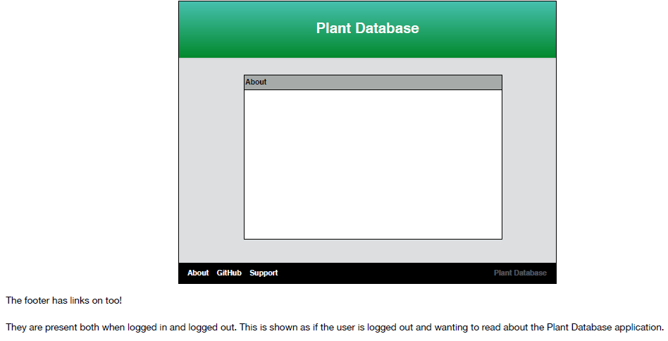

# Database Schema

## Schema Diagram

Below is a graphical view the DB schema along with any relations. This was created using a MySQL database.

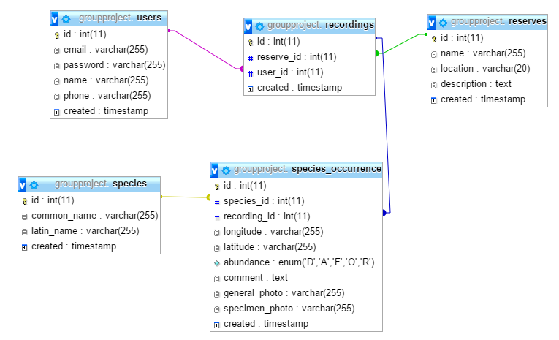

## Description

### Species Tables

So this table would contain both the common and Latin names for the species, which we can obtain from the BSBI list. These would be stored as varchars. It also contains the ID as a primary key and a created timestamp.

### Reserves Table

The reserves table would contain the name, location (OS grid ref as per spec) and description of the reserve. The name and location would be stored as varchar and the description would be stored as text. As before it would contain the ID as the primary key and a created timestamp.

### Recordings Table

The recordings table would contain a reserve ID which would be related to the primary key of the reserves table. It also contains the user’s ID which would be related to the primary key of the users table. As before it also contains its own ID as the primary key and a created timestamp.

### Species Occurrence Table

The species_occurrence table contains both the species ID and the recording ID which are both related to the relevant tables. This would contain each individual occurrence of a species on a per recording basis. This way we would be able to get all the different species recorded on a particular recording and/or on a particular reserve. This table also contains the longitude and latitude of where the species was found, the abundance, a comment, and URLs (?) to both the general and specimen photos. The longitude, latitude and photos will be stored as varchars whereas the comment will be stored as text. In the case of abundance I have used enum as we’re choosing from a specific range of options. As before it also contains ID as its primary key and a created timestamp.

### Users Table

The users table contains the email, phone number and name of the user along with his/her encrypted password. All of these fields are stored as varchar (including phone number due to the fact that it starts with a 0). As before this table also contains ID as its primary key and a created timestamp.

# Android User Interface Design

## 6.2. Main Screen

This is the main title screen it holds the various control buttons for the outline, this allows the users to see all the options available to them. It can also be used for the management of data and a visual representation of currently stored local data. There’s a login button at the top to allow a user to quickly load their application data.

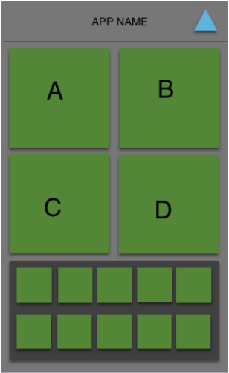

### 

### 

### 6.2.1. Section A/B

Upload button/create new plant recording. Section b is used to manage previous records

### 6.2.2. Section C

Used for Plant Creation

### 6.2.3. Section D

Plant Data Management

## 6.3. Login Screen

Standard login screen allows for the registration or login of accounts.

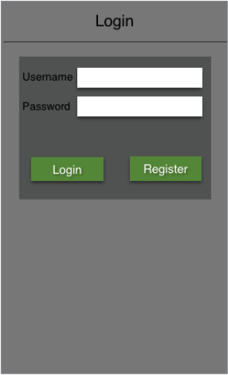

## 6.4. Recording Screen

This allows for the recording and submission of plant data. The image moves left and right in order to switch between close up images and area images, for multiple images you can wipe down on the category.

The plant and reserve boxes allow you to search the relevant databases for the best result, the search screens should be a standard list menu with a search box at the top.

The name box allows the user to enter a name for the record they are adding.

The location box has two options a GPS location pulled from the phones sensors or a manual location entering, this is needed for recordings added offsite and for devices that do not have a GPS sensor.

The notes box allows the botanist to add any extra details that they feel is relevant to the location

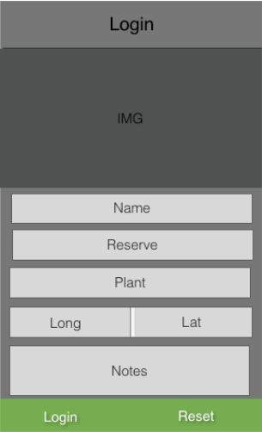

# REFERENCES

N/A

# DOCUMENT HISTORY

|  |  |  |  |  |
| --- | --- | --- | --- | --- |
| Version | CCF No. | Date | Changes made to document | Changed by |
| 1.0 | N/A | 21/10/14 | Document Created and Structured | Add20 |
| 1.2 | N/A | 28/10/14 | Touched up on QA sections to fit specification on QA requirements. Restructured Into new Template Supplied by als48. Database Schema and Descriptions Added. Document put into ‘In Review’ Status | Tcg2 |